**DAILY ONLINE ACTIVITIES SUMMARY**

|  |  |  |  |  |  |  |  |
| --- | --- | --- | --- | --- | --- | --- | --- |
| **Date:** | **6/06/2020** | | | | **Name:** | **Syed Rabeya Aamir** | |
| **Sem & Sec** | **8th B** | | | | **USN:** | **4AL16CS112** | |
| Online Test Summary | | | | | | | |
| **Subject** | | **IOT** | | | | | |
| **Max. Marks** | | **30** | | **Score** | | **30** | |
| Certification Course Summary | | | | | | | |
| **Course** | **Aws cloud practitioner essential** | | | | | | |
| **Certificate Provider** | | | **Aws** | **Duration** | | | **3 hrs** |
| Coding Challenges | | | | | | | |
| **Problem Statement:**  **1)** Python Program for Find largest prime factor of a number. | | | | | | | |
| **Status: Solved** | | | | | | | |
| **Uploaded the report in Github** | | | | **YES** | | | |
| **If yes Repository name** | | | | **rabeya** | | | |
| **Uploaded the report in slack** | | | | **YES** | | | |

**Online Test:**

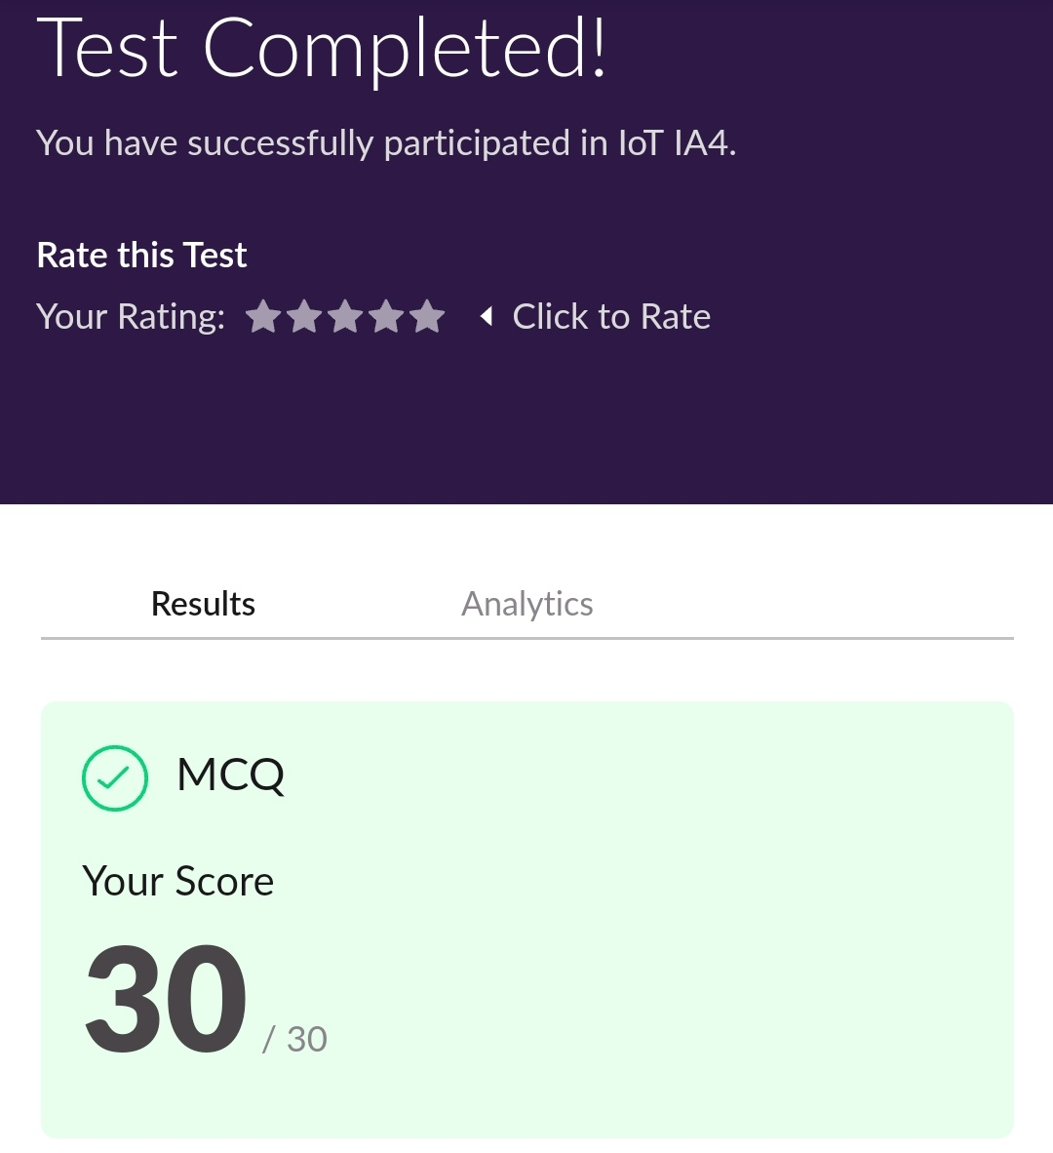

**Certification Course Details:**

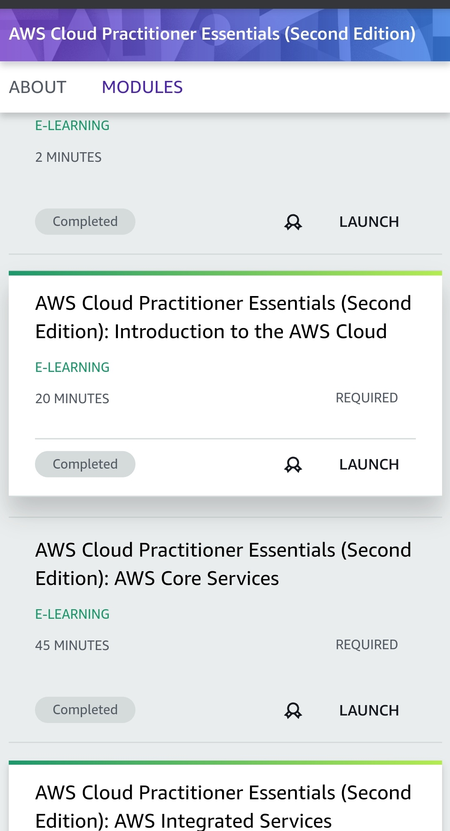

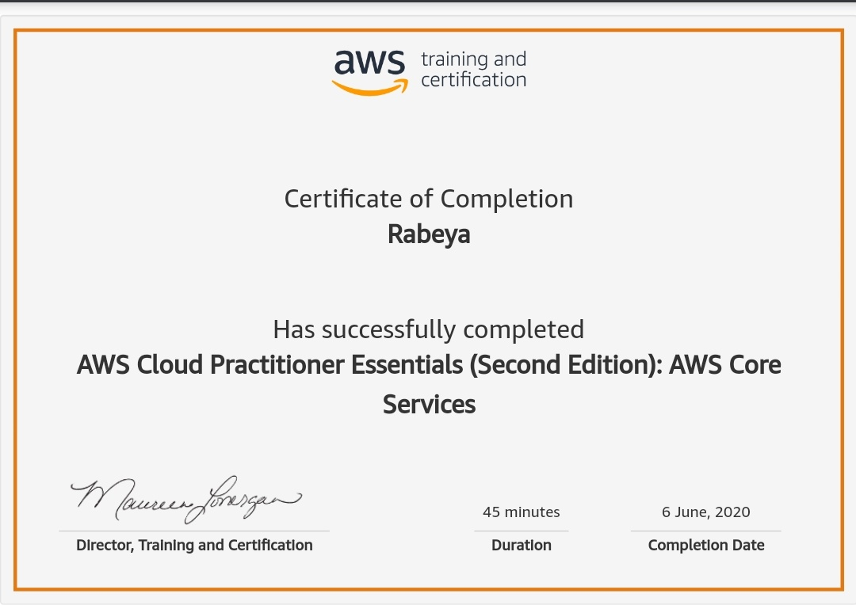

# CODE:

Program no:1

# Python Program for Find largest prime factor of a number.

import math

def maxPrimeFactors (n):

maxPrime = -1

while n % 2 == 0:

maxPrime = 2

n >>= 1

for i in range(3, int(math.sqrt(n)) + 1, 2):

while n % i == 0:

maxPrime = i

n = n / i

if n > 2:

maxPrime = n

return int(maxPrime)

n = 15

print(maxPrimeFactors(n))

n = 25698751364526

print(maxPrimeFactors(n))